CONNECTED COUNTERPARTY METHODOLOGY
Calculation framework for Level 1 and Level 2 relationship risks
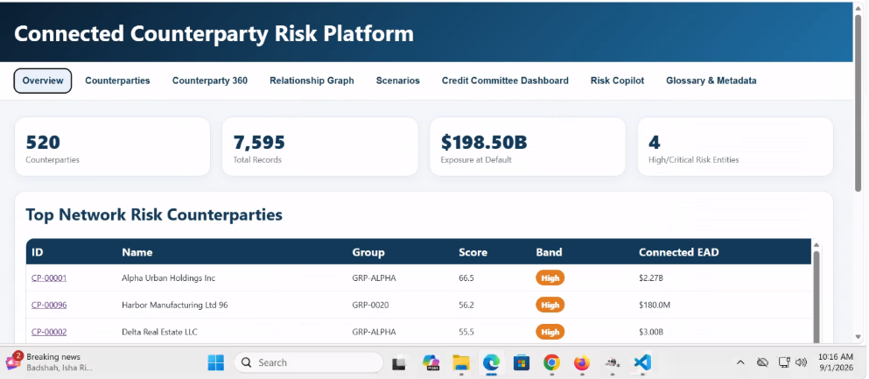
Figure 1. Tab 1
Key Terms: ID = unique counterparty identifier. Name = legal entity name. Group = economic/regulatory group.
1. Common scoring method
1.1 Rating conversion
For every parameter, first assign a rating from 1 to 5.
Rating | Risk level | Normalized score
1 | Very low | 0
2 | Low | 25
3 | Moderate | 50
4 | High | 75
5 | Severe | 100
Use the following conversion:
Normalized Parameter Score= (Parameter Rating - 1) / 4 × 100
For example: Rating 1 = 0
Rating 2 = 25
Rating 3 = 50
Rating 4 = 75
Rating 5 = 100

1.2 Relationship score formula
For a relationship with three parameters:
Relationship Score = Parameter 1 Score × Parameter 1 Weight + Parameter 2 Score × Parameter 2 Weight+ Parameter 3 Score × Parameter 3 Weight
1.3 Relationship score bands
Relationship score | Relationship band | Meaning
0 to 19.9 | Weak | Very limited connection or transmission potential
20 to 39.9 | Moderate | Limited but identifiable relationship
40 to 59.9 | Material | Meaningful control, financial importance or support
60 to 79.9 | Strong | High control or financial dependence
80 to 100 | Critical | Dominant control, importance or direct financial-loss path

L1-01: Parent / Subsidiary:
Category: Legal Ownership. Direction: Parent legal entity -> Subsidiary legal entity. Score meaning: higher score indicates stronger potential for stress to transmit through this relationship.

Parameter | Weight | Formula | Rating thresholds
Ownership and control | 35% | Ownership % = Parent-owned shares ÷ Total subsidiary shares × 100. Also calculate Voting Control % = Parent-controlled votes ÷ Total votes × 100. Use the higher-risk result. | 1: Below 20%, no influence. 2: 20% to below 30%. 3: 30% to below 50%, significant influence. 4: 50% to below 75%, majority control. 5: 75% or more, or unilateral control.
Subsidiary financial materiality | 35% | Revenue Share = Subsidiary revenue ÷ Group revenue × 100. Asset Share = Subsidiary assets ÷ Group assets × 100. EBITDA Share = Subsidiary EBITDA ÷ Group EBITDA × 100. Financial Materiality = 40% Revenue Share + 30% Asset Share + 30% EBITDA Share. | 1: Below 5%. 2: 5% to below 10%. 3: 10% to below 20%. 4: 20% to below 35%. 5: 35% or more.
Parent exposure and support | 30% | Support Exposure = Equity investment + Intercompany loans + Receivables + Guarantees + Expected support. Exposure Ratio = Support Exposure ÷ Parent adjusted capital × 100. | 1: Below 2%. 2: 2% to below 5%. 3: 5% to below 10%. 4: 10% to below 20%. 5: 20% or more.

Parameter | Weight | Purpose
Ownership and control | 35% | Measures the parent’s legal and decision-making control
Subsidiary financial materiality | 35% | Measures how important the subsidiary is to the parent group
Parent financial exposure and support dependency | 30% | Measures the parent’s potential loss and support obligation
Total | 100%

1. Ownership and control
Weight: 35%
This parameter measures how much legal and decision-making control the parent has over the subsidiary
Calculate both:
Ownership percentage = Shares owned by parent ÷ Total outstanding shares of subsidiary× 100

Voting rights percentage = Voting rights controlled by parent ÷ Total voting rights × 100
Rating thresholds
Rating | Ownership and control threshold
1 | Less than 20% ownership and no significant influence
2 | 20% to less than 30%, with limited influence
3 | 30% to less than 50%, with significant influence
4 | 50% to less than 75%, or majority voting control
5 | 75% or more, or unilateral control regardless of ownership percentage

Example
Assume:

Shares held by parent = 800 million
Total subsidiary shares = 1,000 million
Ownership percentage = 800 ÷ 1,000 × 100 = 80%

Because ownership is at least 75%
Ownership and control rating = 5

2. Subsidiary financial materiality (Weight: 35%)
This parameter measures how important the subsidiary is to the overall parent group.
Use three indicators:
- Revenue contribution
- Asset contribution
- EBITDA contribution

Step 2A: Calculate the individual ratios

Revenue contribution = Subsidiary revenue÷ Group revenue × 100
Asset contribution =Subsidiary assets ÷ Group assets × 100
EBITDA contribution = Subsidiary EBITDA ÷ Group EBITDA

Step 2B: Calculate combined financial materiality
Use the following weighting:
Financial Materiality = 40% × Revenue contribution + 30% × Asset contribution + 30% × EBITDA contribution

The 40%, 30% and 30% weights are measurement weights within the parameter. They are different from the 35% weight assigned to the financial-materiality parameter in the final relationship score.

Rating thresholds
Rating | Combined financial materiality
1 | Less than 5%
2 | 5% to less than 10%
3 | 10% to less than 20%

Example
Assume:
Subsidiary revenue = 40,000
Group revenue = 100,000
Revenue contribution
40,000 ÷ 100,000 × 100 = 40%

Subsidiary assets = 30,000
Group assets = 100,000
Asset contribution
30,000 ÷ 100,000 × 100 = 30%

Subsidiary EBITDA = 9,000
Group EBITDA = 20,000
EBITDA contribution
9,000 ÷ 20,000 × 100 = 45%

If subsidiary EBITDA is negative
Do not divide negative subsidiary EBITDA by group EBITDA without review. Instead, use:
- Revenue contribution
- Asset contribution
- Historical three-year average EBITDA contribution
- Subsidiary loss as a percentage of parent capital
- Expected parent support requirement

Combined financial materiality
Financial Materiality = 40% × 40+ 30% × 30 + 30% × 45
= 16 + 9 + 13.5
= 38.5%

The result of 38.5% is at least 35%.
Financial materiality rating = 5

3. Parent financial exposure and support dependency (Weight: 30%)
This parameter measures how much the parent could lose, or may have to provide, if the subsidiary experiences financial difficulty.
Step 3A: Calculate total parent exposure
Include:
Parent Support Exposure = Equity investment+ Intercompany loans+ Intercompany receivables+ Guarantees+ Undrawn support commitments+ Expected recapitalization

Step 3B: Calculate the exposure ratio
Parent Exposure Ratio = Parent Support Exposure÷ Parent adjusted capital× 100

For a non-financial parent, the denominator can be:
- Parent standalone net worth
- Parent liquid resources
- Parent adjusted capital
- Another approved financial-capacity measure
Use the same denominator consistently for every entity.

Rating thresholds
Rating | Parent exposure ratio
1 | Less than 2%
2 | 2% to less than 5%
3 | 5% to less than 10%
4 | 10% to less than 20%
5 | 20% or more

Example
Assume:

Equity investment = 300
Intercompany loan = 100
Intercompany receivable = 50
Guarantee issued = 150
Expected recapitalization = 50

Parent adjusted capital = 10,000
Total support exposure
Parent Support Exposure = 300 + 100 + 50 + 150 + 50
= 650

Exposure ratio
Parent Exposure Ratio= 650 ÷ 10,000 × 100
= 6.5%
The result of 6.5% is between 5% and 10%.
Parent financial exposure rating = 3

4. Convert each rating into points
For each parameter, convert the rating from 1 to 5 into a score from 0 to 100.
Rating | Normalized score
1 | 0
2 | 25
3 | 50
4 | 75
5 | 100
Use:
Normalized Score = (Rating - 1) ÷ 4 × 100

5. Calculate the Parent/Subsidiary Relationship Score
Using the example ratings:
Parameter | Weight | Rating | Normalized score
Ownership and control | 35% | 5 | 100
Subsidiary financial materiality | 35% | 5 | 100
Parent financial exposure and support dependency | 30% | 3 | 50

Formula
Parent/Subsidiary Relationship Score = (35% × Ownership Score) +( 35% × Financial Materiality Score) + (30% × Parent Exposure Score)

Calculation
Relationship Score= (35% × 100 )+ (35% × 100) +( 30% × 50)
= 35 + 35 + 15
= 85
Result
Parent/Subsidiary Relationship Score = 85
This means the relationship has a very strong capacity to transmit risk from the subsidiary to the parent.

6. Relationship-score thresholds
Relationship score | Relationship band | Meaning
0 to 19.9 | Weak | Very limited connection or transmission potential
20 to 39.9 | Moderate | Limited but identifiable relationship
40 to 59.9 | Material | Meaningful control, financial importance or support
60 to 79.9 | Strong | High control or financial dependence
80 to 100 | Critical | Dominant control, importance or direct financial-loss path
Relationship Score = 85
Relationship Band = Critical

7. Include the subsidiary’s current risk
A strong relationship does not automatically mean the parent is currently under stress. The subsidiary must also have a current risk or stress score.
To maintain the same three-parameter structure, use:
Subsidiary risk parameter | Weight
Financial performance and liquidity stress | 40%
Credit and market deterioration | 35%
Operational, legal and reputation events | 25%
Total | 100%

7.1 Financial performance and liquidity stress
Rating | Threshold
1 | EBITDA decline below 5%; strong liquidity; no loss
2 | EBITDA decline from 5% to less than 10%; minor margin pressure
3 | EBITDA decline from 10% to less than 20%; weakening cash flow
4 | EBITDA decline from 20% to less than 35%; recurring losses or covenant pressure
5 | EBITDA decline of 35% or more; severe loss, insolvency concern or covenant breach

7.2 Credit and market deterioration
Rating | Threshold
1 | Stable/improving rating and demand decline below 5%
2 | Minor deterioration or demand decline from 5% to less than 10%
3 | One-notch downgrade or demand decline from 10% to less than 20%
4 | Watchlist/multiple downgrade or demand decline from 20% to less than 35%
5 | Default/near-default or demand decline of 35% or more

7.3 Operational, legal and reputation events
Rating | Threshold
1 | No material event
2 | Minor event with low financial and public impact
3 | Material disruption, litigation or adverse news
4 | Major disruption, regulatory investigation or significant brand impact
5 | Prolonged shutdown, severe fraud, licence threat or group-wide reputation event

8. Example Subsidiary Stress Score
Assume the subsidiary has these ratings:

Subsidiary risk parameter | Weight | Rating | Normalized score
Financial performance and liquidity | 40% | 4 | 75
Credit and market deterioration | 35% | 4 | 75
Operational, legal and reputation events | 25% | 3 | 50

Calculation
Subsidiary Stress Score= (40% × 75) + (35% × 75) + (25% × 50)
= 30 + 26.25 + 12.50
= 68.75

Stress thresholds:
Stress score | Stress band
0 to 19.9 | Very low
20 to 39.9 | Low
40 to 59.9 | Moderate
60 to 79.9 | High
80 to 100 | Severe
Subsidiary Stress Score = 68.75
Subsidiary Stress Band = High

9. Calculate risk transmitted to the parent
Basic formula
Subsidiary Risk Contribution to Parent= Relationship Score× Subsidiary Stress Score ÷ 100
Using the example:
Risk Contribution= 85 × 68.75 ÷ 100
= 58.44

Therefore:
Risk transmitted to parent= 58.44
Contribution thresholds
Contribution score | Transmission level
0 to 19.9 | Low
20 to 39.9 | Moderate
40 to 59.9 | Elevated
60 to 79.9 | High
80 to 100 | Critical
Therefore: 58.44 = Elevated risk contribution

11. Complete scoring flow
Ownership and control rating = 5
Financial materiality rating = 5
Parent exposure rating = 3

Relationship Score = 85
Relationship Band = Critical

Subsidiary Stress Score = 68.75
Subsidiary Stress Band = High

Risk Contribution to Parent
= 85 × 68.75 ÷ 100
= 58.44
Transmission Level = Elevated

L1-02: Ultimate Beneficial Owner
Category: Beneficial Ownership. Direction: UBO / controlling party -> Customer or legal entity. Score meaning: higher score indicates stronger potential for stress to transmit through this relationship.

Parameter | Weight | Formula | Rating thresholds
Effective ultimate ownership | 40% | Effective Ownership % = Ownership percentage at Layer 1 × Layer 2 × remaining layers. Example: 80% × 60% = 48%. Add parallel ownership paths where legally appropriate. | 1: Below 10%. 2: 10% to below 20%. 3: 20% to below 30%. 4: 30% to below 50%. 5: 50% or more.
Voting and control rights | 35% | Control Coverage % = Voting rights controlled + equivalent board or reserved-matter control, converted to an approved 0 to 100 control measure. Use the strongest verified control right. | 1: No control. 2: Minor protective rights. 3: Significant influence. 4: De facto control or major veto. 5: Absolute or unilateral control.
Ownership-path complexity | 25% | Complexity Index = Additional ownership layers + 2 × Nominee/trust arrangements + 2 × Unverified entities + Higher-risk jurisdiction points. ( It is multiplied by 2 because nominee or trust arrangements and unverified entities are being treated as twice as significant as a normal ownership layer. The number 2 is a chosen risk weight, not a mandatory regulatory constant.) | 1: 0 to 1 point. 2: 2 to 3. 3: 4 to 5. 4: 6 to 8. 5: Above 8 or a material part of the path is unverified.

L1-03: Common Shareholder
Category: Ownership / Control. Direction: Shareholder -> Multiple investee entities. Score meaning: higher score indicates stronger potential for stress to transmit through this relationship.

Parameter | Weight | Formula | Rating thresholds
Common shareholder holding | 40% | Common Holding % = Minimum of shareholder ownership in Entity A and shareholder ownership in Entity B. | 1: Below 10%. 2: 10% to below 20%. 3: 20% to below 30%. 4: 30% to below 50%. 5: 50% or more.
Common control rights | 35% | Control Coverage % = Shared shareholder-controlled board seats or voting rights ÷ Relevant total seats or votes × 100. | 1: Below 10%. 2: 10% to below 20%. 3: 20% to below 35%. 4: 35% to below 50%. 5: 50% or more.
Intercompany dependency | 25% | Dependency % = Transactions + Funding + Guarantees between linked entities ÷ Relevant revenue, funding, or debt total × 100. | 1: Below 5%. 2: 5% to below 10%. 3: 10% to below 20%. 4: 20% to below 35%. 5: 35% or more.

L1-04: Common Director / Officer
Category: Governance. Direction: Director / officer -> Legal entities. Score meaning: higher score indicates stronger potential for stress to transmit through this relationship.

Parameter | Weight | Formula | Rating thresholds
Board overlap | 40% | Board Overlap % = Number of shared directors ÷ Number of directors on the smaller board × 100. | 1: Below 10%. 2: 10% to below 20%. 3: 20% to below 35%. 4: 35% to below 50%. 5: 50% or more.
Decision authority | 35% | Decision Authority % = Critical decision areas controlled by shared persons ÷ Total defined critical decision areas × 100. Areas may include finance, risk, strategy, procurement, and operations. | 1: Below 10%. 2: 10% to below 25%. 3: 25% to below 50%. 4: 50% to below 75%. 5: 75% or more.
Overlapping tenure | 25% | Overlap Tenure = Minimum active overlapping appointment period across the two entities. | 1: Inactive or below 3 months. 2: 3 months to below 1 year. 3: 1 to below 3 years. 4: 3 to below 5 years. 5: 5 years or more.

L1-05: Economic / Borrower / Regulatory Group
Category: Formal Grouping. Direction: Group identifier -> Member entity. Score meaning: higher score indicates stronger potential for stress to transmit through this relationship.

Parameter | Weight | Formula | Rating thresholds
Formal group classification | 40% | Classification Rating = Approved rating mapped from the bank’s formal group type and grouping rationale. | 1: Informational group. 2: Candidate group under review. 3: Approved borrower group. 4: Approved economic group. 5: Regulatory connected group.
Group EAD concentration | 35% | Group EAD Concentration % = Connected Group EAD ÷ Relevant portfolio EAD × 100. A capital-based denominator may also be used under policy. | 1: Below 5%. 2: 5% to below 10%. 3: 10% to below 20%. 4: 20% to below 35%. 5: 35% or more.
Intra-group financial dependency | 25% | Dependency % = Intra-group funding + Guarantees + Cash-pool balances ÷ Group funding or debt × 100. | 1: Below 5%. 2: 5% to below 10%. 3: 10% to below 20%. 4: 20% to below 35%. 5: 35% or more.

L1-06: Guarantor Relationship
Category: Credit Support. Direction: Guarantor -> Borrower / facility. Score meaning: higher score indicates stronger potential for stress to transmit through this relationship.

Parameter | Weight | Formula | Rating thresholds
Guarantee coverage | 40% | Guarantee Coverage % = Enforceable guarantee amount ÷ Supported exposure × 100. | 1: Below 10%. 2: 10% to below 25%. 3: 25% to below 50%. 4: 50% to below 80%. 5: 80% or more.
Guarantor burden | 35% | Guarantor Burden % = Total potential guarantee calls ÷ Guarantor adjusted capital × 100. | 1: Below 5%. 2: 5% to below 10%. 3: 10% to below 20%. 4: 20% to below 35%. 5: 35% or more.
Borrower support dependency | 25% | Support Dependency % = Funding supported by guarantor ÷ Total borrower funding × 100. | 1: Below 10%. 2: 10% to below 25%. 3: 25% to below 50%. 4: 50% to below 80%. 5: 80% or more.

L1-07: Cross Guarantee
Category: Credit Support. Direction: Guaranteeing entity -> Guaranteed entity / facility. Score meaning: higher score indicates stronger potential for stress to transmit through this relationship.

Parameter | Weight | Formula | Rating thresholds
Cross-guarantee coverage | 40% | Coverage % = Cross-guaranteed obligations ÷ Combined entity debt × 100. | 1: Below 10%. 2: 10% to below 25%. 3: 25% to below 50%. 4: 50% to below 80%. 5: 80% or more.
Guarantee-chain complexity | 25% | Complexity Score = Number of guarantee links + 3 points for a circular guarantee + 2 points for each unresolved legal link. | 1: One simple link. 2: Two links. 3: Three links. 4: Four or more non-circular links. 5: Circular, opaque, or unresolved chain.
Joint guarantee burden | 35% | Joint Burden % = Potential calls across the guarantee network ÷ Combined adjusted capital of guarantors × 100. | 1: Below 5%. 2: 5% to below 10%. 3: 10% to below 20%. 4: 20% to below 35%. 5: 35% or more.

L1-08: Shared Collateral / Collateral Provider
Category: Collateral. Direction: Collateral asset / provider -> Facilities / borrowers. Score meaning: higher score indicates stronger potential for stress to transmit through this relationship.

Parameter | Weight | Formula | Rating thresholds
Collateral utilisation | 40% | Collateral Utilisation % = Total secured claims ÷ Eligible collateral value after approved haircut × 100. | 1: Below 50%. 2: 50% to below 70%. 3: 70% to below 90%. 4: 90% to 110%. 5: Above 110%.
Shared-asset concentration | 30% | Concentration % = Largest shared asset value ÷ Total eligible collateral value × 100. | 1: Below 10%. 2: 10% to below 20%. 3: 20% to below 35%. 4: 35% to below 50%. 5: 50% or more.
Collateral risk adjustment | 30% | Collateral Risk % = Approved market haircut + Valuation-age adjustment + Lien/legal-priority adjustment. | 1: Below 10%. 2: 10% to below 20%. 3: 20% to below 35%. 4: 35% to below 50%. 5: 50% or more, or unperfected/disputed collateral.

L1-09: Joint Venture / Affiliate
Category: Legal Structure. Direction: Investor / affiliate -> JV or affiliate entity. Score meaning: higher score indicates stronger potential for stress to transmit through this relationship.

Parameter | Weight | Formula | Rating thresholds
Ownership and control | 35% | JV Control % = Highest of ownership percentage, voting-right percentage, or board-control percentage. | 1: Below 10%. 2: 10% to below 20%. 3: 20% to below 50%, influence only. 4: Joint control. 5: Dominant or de facto control.
Capital commitment | 35% | Commitment Ratio % = Equity commitment + Shareholder loans + Guarantees ÷ Investor adjusted capital × 100. | 1: Below 2%. 2: 2% to below 5%. 3: 5% to below 10%. 4: 10% to below 20%. 5: 20% or more.
Strategic cash-flow dependency | 30% | Dependency % = Revenue, purchases, dividends, or off-take linked to JV ÷ Relevant entity total × 100. | 1: Below 5%. 2: 5% to below 10%. 3: 10% to below 20%. 4: 20% to below 35%. 5: 35% or more.

L1-10: Syndicated Facility Membership
Category: Facility / Lending. Direction: Borrower / lender / agent -> Syndicated facility. Score meaning: higher score indicates stronger potential for stress to transmit through this relationship.

Parameter | Weight | Formula | Rating thresholds
Facility materiality | 40% | Facility Exposure = Drawn amount + Undrawn commitment × CCF. Facility Materiality % = Facility Exposure ÷ Total borrower debt × 100. | 1: Below 5%. 2: 5% to below 10%. 3: 10% to below 20%. 4: 20% to below 35%. 5: 35% or more.
Covenant/default linkage | 30% | Default Linkage % = Debt subject to cross-default or acceleration ÷ Total borrower debt × 100. | 1: Below 10%. 2: 10% to below 25%. 3: 25% to below 50%. 4: 50% to below 80%. 5: 80% or more, or automatic cross-default.
Refinancing proximity | 30% | Months to Maturity = Facility maturity date minus calculation date, converted into months. | 1: More than 36 months. 2: 24 to 36 months. 3: 12 to below 24 months. 4: 6 to below 12 months. 5: Below 6 months.

L1-11: Branch / Head Office
Category: Legal Structure. Direction: Head office legal entity -> Branch. Score meaning: higher score indicates stronger potential for stress to transmit through this relationship.

Parameter | Weight | Formula | Rating thresholds
Head-office funding dependency | 40% | Funding Dependency % = Net funding received from head office ÷ Branch total funding × 100. Legal status acts as an override where the branch and head office are the same legal entity. | 1: Below 10% and legally separate. 2: 10% to below 25%. 3: 25% to below 50%. 4: 50% to below 80%. 5: 80% or more, or the same legal entity.
Branch financial materiality | 35% | Materiality % = 40% Branch Asset Share + 30% Branch Revenue Share + 30% Branch EAD Share. | 1: Below 5%. 2: 5% to below 10%. 3: 10% to below 20%. 4: 20% to below 35%. 5: 35% or more.
Jurisdiction and transfer risk | 25% | Jurisdiction Score = Approved country, transfer, convertibility, ring-fencing, and resolution-risk score normalized to 0 to 100. | 1: 0 to below 20. 2: 20 to below 40. 3: 40 to below 60. 4: 60 to below 80. 5: 80 to 100 or blocked transfer.

3. Level 2 Relationships
Level 2 relationships represent economic, transactional, market, supply-chain, operational, sector, geographic, logistics, commodity, and contractual dependencies. The workbook notes that inferred Level 2 relationships should retain the observation window, source evidence, materiality measure, and confidence
L2-01 | Supplier Relationship
Category: Supply Chain. Direction: Supplier -> Buyer / borrower. Score meaning : higher score indicates stronger potential for stress to transmit through this relationship.

Parameter | Weight | Formula | Rating thresholds
Purchase dependency | 40% | Purchase Dependency % = Purchases from supplier ÷ Total purchases × 100. | 1: Below 5%. 2: 5% to below 10%. 3: 10% to below 20%. 4: 20% to below 35%. 5: 35% or more.
Supplier replacement time | 30% | Replacement Time = Estimated months required to qualify, contract, and activate an alternative supplier. | 1: Below 1 month. 2: 1 to below 3 months. 3: 3 to below 6 months. 4: 6 to below 12 months. 5: 12 months or more, or no alternative supplier.
Production dependency | 30% | Production Dependency % = Output dependent on supplier input ÷ Total output × 100. | 1: Below 10%. 2: 10% to below 25%. 3: 25% to below 50%. 4: 50% to below 75%. 5: 75% or more, or production stops without the supplier.

L2-02 | Customer / Off-taker Relationship
Category: Revenue Dependency. Direction: Borrower / seller -> Customer / off-taker. Score meaning: higher score indicates stronger potential for stress to transmit through this relationship.

Parameter | Weight | Formula | Rating thresholds
Revenue concentration | 40% | Revenue Concentration % = Revenue from customer ÷ Total revenue × 100. | 1: Below 5%. 2: 5% to below 10%. 3: 10% to below 20%. 4: 20% to below 35%. 5: 35% or more.
Receivables concentration | 30% | Receivables Concentration % = Receivables from customer ÷ Total receivables × 100. | 1: Below 5%. 2: 5% to below 10%. 3: 10% to below 20%. 4: 20% to below 35%. 5: 35% or more.
Overdue receivables | 30% | Overdue Ratio % = Customer receivables overdue beyond approved period ÷ Total receivables from customer × 100. | 1: Below 5%. 2: 5% to below 10%. 3: 10% to below 20%. 4: 20% to below 35%. 5: 35% or more, or specifically impaired.

L2-03 | Multi-tier Supply Chain Network
Category: Supply Chain. Direction: Upstream / downstream entity -> Connected entity. Score meaning: higher score indicates stronger potential for stress to transmit through this relationship.

Parameter | Weight | Formula | Rating thresholds
Path dependency | 40% | Path Dependency % = Dependency at Edge 1 × Dependency at Edge 2 × remaining edge dependencies. Example: 60% × 50% = 30%. | 1: Below 2%. 2: 2% to below 5%. 3: 5% to below 10%. 4: 10% to below 20%. 5: 20% or more.
Critical-node concentration | 35% | Node Concentration % = Critical supply paths passing through node ÷ Total identified critical paths × 100. | 1: Below 5%. 2: 5% to below 10%. 3: 10% to below 20%. 4: 20% to below 35%. 5: 35% or more.
Supply-path depth | 25% | Path Depth = Number of relationship edges in the shortest relevant supply path. | 1: More than 5 tiers. 2: 4 to 5 tiers. 3: 3 tiers. 4: 2 tiers. 5: Direct or near-direct critical dependency.

L2-04 | Shared Funding Source
Category: Funding. Direction: Funding provider -> Borrowers / issuers. Score meaning: higher score indicates stronger potential for stress to transmit through this relationship.

Parameter | Weight | Formula | Rating thresholds
Funding dependency | 40% | Funding Dependency % = Funding from shared provider or market ÷ Total funding × 100. | 1: Below 5%. 2: 5% to below 10%. 3: 10% to below 20%. 4: 20% to below 35%. 5: 35% or more.
Refinancing proximity | 30% | Months to Refinancing = Refinancing date minus calculation date, converted into months. | 1: More than 36 months. 2: 24 to 36 months. 3: 12 to below 24 months. 4: 6 to below 12 months. 5: Below 6 months.
Alternative funding coverage | 30% | Coverage % = Available alternative lines + Unrestricted liquidity ÷ Funding due within 12 months × 100. | 1: 150% or more. 2: 120% to below 150%. 3: 100% to below 120%. 4: 75% to below 100%. 5: Below 75%.

L2-05 | Shared Equity Sponsor / Family Office
Category: Investor Network. Direction: Sponsor / investor -> Portfolio companies. Score meaning :higher score indicates stronger potential for stress to transmit through this relationship.

Parameter | Weight | Formula | Rating thresholds
Sponsor ownership and control | 40% | Sponsor Control % = Highest ownership percentage, voting-right percentage, or board-control percentage. | 1: Below 10%. 2: 10% to below 20%. 3: 20% to below 50%, significant influence. 4: Joint or de facto control. 5: Majority control.
Sponsor funding dependency | 35% | Funding Dependency % = Sponsor equity + Shareholder loans + Sponsor guarantees ÷ Total entity funding × 100. | 1: Below 5%. 2: 5% to below 10%. 3: 10% to below 20%. 4: 20% to below 35%. 5: 35% or more.
Portfolio correlation | 25% | Portfolio Correlation % = Portfolio companies sharing the same primary sector, geography, or funding strategy ÷ Total relevant portfolio companies × 100. | 1: Below 10%. 2: 10% to below 25%. 3: 25% to below 50%. 4: 50% to below 75%. 5: 75% or more.

L2-06 | Material Payment / Cash-flow Relationship
Category: Transaction Network. Direction: Payer -> Payee. Score meaning: higher score indicates stronger potential for stress to transmit through this relationship.

Parameter | Weight | Formula | Rating thresholds
Payment-flow materiality | 40% | Flow Materiality % = Payment value with connected entity ÷ Total relevant inflows or outflows × 100. Calculate inflows and outflows separately and use the relevant risk direction. | 1: Below 5%. 2: 5% to below 10%. 3: 10% to below 20%. 4: 20% to below 35%. 5: 35% or more.
Payment persistence | 25% | Persistence % = Months with qualifying payment activity ÷ Months in observation window × 100. | 1: Below 20%. 2: 20% to below 40%. 3: 40% to below 60%. 4: 60% to below 80%. 5: 80% or more.
Payment-flow disruption | 35% | Flow Reduction % = Historical average flow minus current flow ÷ Historical average flow × 100. | 1: Below 5%. 2: 5% to below 10%. 3: 10% to below 20%. 4: 20% to below 35%. 5: 35% or more, or flow has stopped.

L2-07 | Treasury Counterparty Relationship
Category: Markets / Treasury. Direction: Treasury counterparty -> Bank / fund / client. Score meaning: higher score indicates stronger potential for stress to transmit through this relationship.

Parameter | Weight | Formula | Rating thresholds
Net exposure materiality | 40% | Net Exposure = Current Exposure + Potential Future Exposure - Eligible Collateral. Exposure Ratio % = Net Exposure ÷ Approved counterparty limit or capital measure × 100. | 1: Below 2%. 2: 2% to below 5%. 3: 5% to below 10%. 4: 10% to below 20%. 5: 20% or more.
Wrong-way-risk ratio | 30% | Wrong-way Risk % = Exposure positively linked to the counterparty’s stress factors ÷ Total net exposure × 100. | 1: Below 5%. 2: 5% to below 10%. 3: 10% to below 20%. 4: 20% to below 35%. 5: 35% or more, or specific wrong-way risk exists.
Unsecured exposure | 30% | Unsecured Exposure % = Exposure not covered by enforceable netting or eligible collateral ÷ Gross exposure × 100. | 1: Below 10%. 2: 10% to below 25%. 3: 25% to below 50%. 4: 50% to below 75%. 5: 75% or more.

L2-08 | Common Outsourcing / Technology Provider
Category: Operational Dependency. Direction: Service provider -> Dependent companies. Score meaning: higher score indicates stronger potential for stress to transmit through this relationship.

Parameter | Weight | Formula | Rating thresholds
Critical workload dependency | 40% | Workload Dependency % = Critical business operations supported by provider ÷ Total critical operations × 100. | 1: Below 10%. 2: 10% to below 20%. 3: 20% to below 35%. 4: 35% to below 50%. 5: 50% or more.
Provider replacement time | 30% | Replacement Time = Estimated months required to contract, migrate, test, and activate an approved alternative. | 1: Below 1 month. 2: 1 to below 3 months. 3: 3 to below 6 months. 4: 6 to below 12 months. 5: 12 months or more, or no alternative.
Critical service failure rate | 30% | Failure Rate % = Critical SLA(Service Level Agreement) failures ÷ Total measured critical SLA obligations × 100. | 1: Below 1%. 2: 1% to below 3%. 3: 3% to below 5%. 4: 5% to below 10%. 5: 10% or more, or an ongoing critical outage.

L2-09 | Common Insurer / Credit Protection Provider
Category: Risk Transfer. Direction: Insurer / protection seller -> Policyholder / exposure. Score meaning: higher score indicates stronger potential for stress to transmit through this relationship.

Parameter | Weight | Formula | Rating thresholds
Coverage dependency | 40% | Coverage Dependency % = Protected exposure ÷ Gross exposure × 100. | 1: Below 10%. 2: 10% to below 25%. 3: 25% to below 50%. 4: 50% to below 80%. 5: 80% or more.
Provider capacity burden | 35% | Capacity Burden % = Estimated correlated claims ÷ Provider available claims-paying capacity × 100. | 1: Below 5%. 2: 5% to below 10%. 3: 10% to below 20%. 4: 20% to below 35%. 5: 35% or more.
Policy-expiry proximity | 25% | Months to Expiry = Policy expiry date minus calculation date, converted into months. | 1: More than 36 months. 2: 24 to 36 months. 3: 12 to below 24 months. 4: 3 to below 12 months. 5: Below 3 months, or no replacement cover

L2-10 | Industry Ecosystem
Category: Sector Ecosystem. Direction: Industry / ecosystem node -> Companies. Score meaning: higher score indicates stronger potential for stress to transmit through this relationship.
Parameter | Weight | Formula | Rating thresholds
Sector concentration | 40% | Sector Concentration % = Revenue or EBITDA from sector ÷ Total revenue or EBITDA × 100. Use the most relevant measure for the business model. | 1: Below 10%. 2: 10% to below 20%. 3: 20% to below 35%. 4: 35% to below 50%. 5: 50% or more.
Sector demand decline | 35% | Demand Decline % = Historical sector demand minus current sector demand ÷ Historical sector demand × 100. | 1: Below 5%. 2: 5% to below 10%. 3: 10% to below 20%. 4: 20% to below 35%. 5: 35% or more.
Entity resilience coverage | 25% | Resilience Coverage % = Unrestricted liquidity + Available committed lines ÷ Stressed 12-month cash requirement × 100. | 1: 150% or more. 2: 120% to below 150%. 3: 100% to below 120%. 4: 75% to below 100%. 5: Below 75%.

L2-11| Geographic Dependency
Category: Sector Ecosystem. Direction: Industry / ecosystem node -> Companies. Score meaning: higher score indicates stronger potential for stress to transmit through this relationship.

Parameter | Weight | Formula | Rating thresholds
Geographic concentration | 40% | Geographic Concentration % = 40% Revenue Share + 30% Asset Share + 30% Supplier or Operational Share in the geography. | 1: Below 10%. 2: 10% to below 20%. 3: 20% to below 35%. 4: 35% to below 50%. 5: 50% or more.
Country-risk score | 35% | Country Risk Score = Approved sovereign, macroeconomic, transfer, political, climate, and security risk score normalized to 0 to 100. | 1: 0 to below 20. 2: 20 to below 40. 3: 40 to below 60. 4: 60 to below 80. 5: 80 to 100.
Unmitigated geographic exposure | 25% | Unmitigated Exposure % = Exposure not covered by insurance, hedging, or alternative operations ÷ Total geographic exposure × 100. | 1: Below 10%. 2: 10% to below 25%. 3: 25% to below 50%. 4: 50% to below 75%. 5: 75% or more.

L2-12 | Shared Port / Route / Carrier Dependency
Category: Logistics. Direction: Logistics node / provider -> Companies. Score meaning: higher score indicates stronger potential for stress to transmit through this relationship.
Parameter | Weight | Formula | Rating thresholds
Shipment concentration | 40% | Shipment Concentration % = Shipment volume or value through shared node ÷ Total shipment volume or value × 100. | 1: Below 10%. 2: 10% to below 20%. 3: 20% to below 35%. 4: 35% to below 50%. 5: 50% or more.
Diversion coverage | 30% | Diversion Coverage % = Available alternative route capacity ÷ Volume dependent on shared node × 100. | 1: 100% or more. 2: 75% to below 100%. 3: 50% to below 75%. 4: 25% to below 50%. 5: Below 25%.
Inventory buffer | 30% | Inventory Buffer Ratio = Inventory days available ÷ Expected disruption days. | 1: 3.0 or more. 2: 2.0 to below 3.0. 3: 1.0 to below 2.0. 4: 0.5 to below 1.0. 5: Below 0.5

L2-13 | Energy / Commodity Dependency
Category: Physical / Commodity. Direction: Commodity / infrastructure -> Companies. Score meaning: higher score indicates stronger potential for stress to transmit through this relationship.
Parameter | Weight | Formula | Rating thresholds
Commodity dependency | 40% | Commodity Dependency % = Commodity-related cost or revenue ÷ Total cost or revenue × 100. Select cost or revenue according to whether the entity is a consumer or producer. | 1: Below 10%. 2: 10% to below 20%. 3: 20% to below 35%. 4: 35% to below 50%. 5: 50% or more.
Price-shock impact | 35% | Price-shock Impact % = Absolute stressed EBITDA reduction ÷ Base EBITDA × 100. | 1: Below 5%. 2: 5% to below 10%. 3: 10% to below 20%. 4: 20% to below 35%. 5: 35% or more.
Unhedged exposure | 25% | Unhedged Exposure % = Commodity volume or value not effectively hedged ÷ Total commodity exposure × 100. | 1: Below 20%. 2: 20% to below 40%. 3: 40% to below 60%. 4: 60% to below 80%. 5: 80% or more.

L2-14 | Joint Commercial Contract / Consortium
Category: Contractual Alliance. Direction: Participant -> Project / consortium. Score meaning: higher score indicates stronger potential for stress to transmit through this relationship.
Parameter | Weight | Formula | Rating thresholds
Contract or project materiality | 40% | Contract Materiality % = Contract revenue, project value, or committed capital ÷ Entity annual revenue or adjusted capital × 100. | 1: Below 5%. 2: 5% to below 10%. 3: 10% to below 20%. 4: 20% to below 35%. 5: 35% or more.
Shared-liability ratio | 35% | Shared Liability % = Joint, guaranteed, or cross-default liability ÷ Total entity project exposure × 100. | 1: Below 10%. 2: 10% to below 25%. 3: 25% to below 50%. 4: 50% to below 80%. 5: 80% or more, or uncapped joint liability.
Project-delay ratio | 25% | Project Delay % = Actual or forecast delayed days ÷ Original project duration days × 100. | 1: Below 5%. 2: 5% to below 10%. 3: 10% to below 20%. 4: 20% to below 35%. 5: 35% or more, project default, or termination.

4.Connected-entity stress score
The relationship score measures the strength of the connection. It does not indicate whether the connected entity is currently distressed.
Use the following three common stress parameters for every connected entity.
Stress parameter | Weight | Calculation | Rating thresholds
Financial and liquidity stress | 40% | Stress Measure = 40% EBITDA decline + 30% Operating cash-flow decline + 30% Liquidity-buffer reduction. | 1: Below 5%. 2: 5% to below 10%. 3: 10% to below 20%. 4: 20% to below 35%. 5: 35% or more, severe loss, covenant breach, or insolvency concern.
Credit and market deterioration | 35% | Stress Measure = 50% Normalized rating-migration score + 50% Demand, spread, or market-value deterioration. | 1: Below 5%. 2: 5% to below 10%. 3: 10% to below 20%. 4: 20% to below 35%. 5: 35% or more, near default, or default.
Operational, legal, and reputation event | 25% | Assign an event severity based on duration, financial impact, regulatory consequence, and business interruption. | 1: No material event. 2: Minor short event. 3: Material disruption or litigation. 4: Major disruption or investigation. 5: Prolonged shutdown, fraud, sanctions, licence threat, or equivalent critical event.

Stress score formula
Connected Entity Stress Score = Financial Stress Score × 40%+ Credit and Market Stress Score × 35%
+ Event Stress Score × 25%

5. Relationship risk contribution
After calculating the relationship score and connected-entity stress score:
Relationship Contribution= Relationship Score× Connected Entity Stress Score / 100× Direction Factor× Confidence Factor× Exposure Factor

5.1 Direction factor

Relationship path | Factor
Direct legal, contractual, or financial link | 1
Strong indirect relationship | 0.75
Moderate indirect relationship | 0.5
Weak or ancillary relationship | 0.25

5.2 Confidence Factor

Confidence Score = 50% Source Quality + 30% Data Freshness + 20% Verification Status

Threshold:
Score | Confidence
90-100 | Very High
75-89 | High
50-74 | Medium
<50 | Low

Conversion:
Confidence Factor = Confidence Score / 100
Example:
Confidence Score = 94
Confidence Factor = 0.94
Use the same confidence score everywhere.

5.3 Exposure factor
A simple initial exposure factor can be used:
Connected EAD relative to entity or group limit | Factor
Below 10% | 0.75
10% to below 25% | 0.9
25% to below 50% | 1
50% to below 75% | 1.1
75% or more | 1.25

Example
Relationship Score = 85.00
Connected Stress Score = 68.75
Direction Factor = 1.00
Confidence Factor = 0.85
Exposure Factor = 1.00
Relationship Contribution = 85 × 68.75 / 100 × 1.00 × 0.85 × 1.00
= 49.67

6. Network Risk Score
Do not directly add all relationship contributions because the score could exceed 100.
Use the complement-of-product formula:
Network Risk Score = 100 × [1 - Π(1 - Relationship Contribution / 100)]

Network Risk Score is calculated centrally. All tabs consume the same value. No local recalculation is permitted.

Example

Assume:
Relationship | Contribution
Parent/Subsidiary | 49.67
Supplier | 25
Shared Funding | 20
Network Risk Score = 100 × [1 - (1 - 0.4967)× (1 - 0.2500) × (1 - 0.2000)]
= 100 × [1 - 0.5033 × 0.75 × 0.80]
= 69.80

7. Final Tab 1 score calculation

These four scores are designed to answer four different questions about a counterparty: How risky is the entity itself, how concentrated are its exposures, what adverse events are affecting it, and how much additional risk comes from its connections? The final score in Tab 1 should combine them into one comparable score, rather than relying on only one dimension.

The Tab 1 screenshot displays a single counterparty Score, Band, Group, and Connected EAD. A proposed explainable formula is:
Final Counterparty Risk Score= Standalone Risk Score × 45%+ Network Risk Score × 35%+ Concentration Risk Score × 10%+ Event Risk Score × 10%

This score is the official counterparty score. All other tabs display this score. No module may derive an alternative Final Risk Score.

7.1 Final score components
Component | Weight | Purpose
Standalone Risk Score | 45% | Counterparts’ own financial, credit, liquidity, and covenant risk
Network Risk Score | 35% | Combined Level 1 and Level 2 relationship contributions
Concentration Risk Score | 10% | Group, sector, geography, product, collateral, and funding concentration
Event Risk Score | 10% | Current financial, legal, operational, market, governance, or reputation events

7.2 Standalone Risk Score
Standalone Risk Score = Financial Risk × 40% + Credit Risk × 35% + Liquidity and Covenant Risk × 25%

7.3 Concentration Risk Score
Concentration Risk Score = Group and EAD Concentration × 40% + Sector and Geographic Concentration × 35% + Product and Collateral Concentration × 25%

7.4 Event Risk Score
Event Risk Score= Financial and Credit Event Severity × 40%+ Operational and Legal Event Severity × 35%+ Reputation and Market Event Severity × 25%
8. Worked Tab 1 example
Component | Score | Weight | Weighted contribution
Standalone Risk | 58 | 45% | 26.1
Network Risk | 69.8 | 35% | 24.43
Concentration Risk | 62 | 10% | 6.2
Event Risk | 68 | 10% | 6.8
Final score |  | 100% | 63.53

Final Score= (58.00 × 45%) + (69.80 × 35%) + (62.00 × 10%) + (68.00 × 10%)
= 26.10 + 24.43 + 6.20 + 6.80
= 63.53

9. Final Tab 1 bands

Final counterparty score | Final band | Suggested colour | Recommended action
0 to 19.99 | Low | Green | Normal monitoring
20 to 39.99 | Moderate | Blue | Standard review and periodic refresh
40 to 59.99 | Elevated | Amber | Enhanced monitoring and relationship review
60 to 79.99 | High | Orange | Credit review, scenario analysis, and limit assessment
80 to 100 | Critical | Red | Immediate escalation and senior credit action

Final Counterparty Risk Score = 63.53
Final Band = High

Tab 2: Counterparties Explorer - Detailed Functional Document

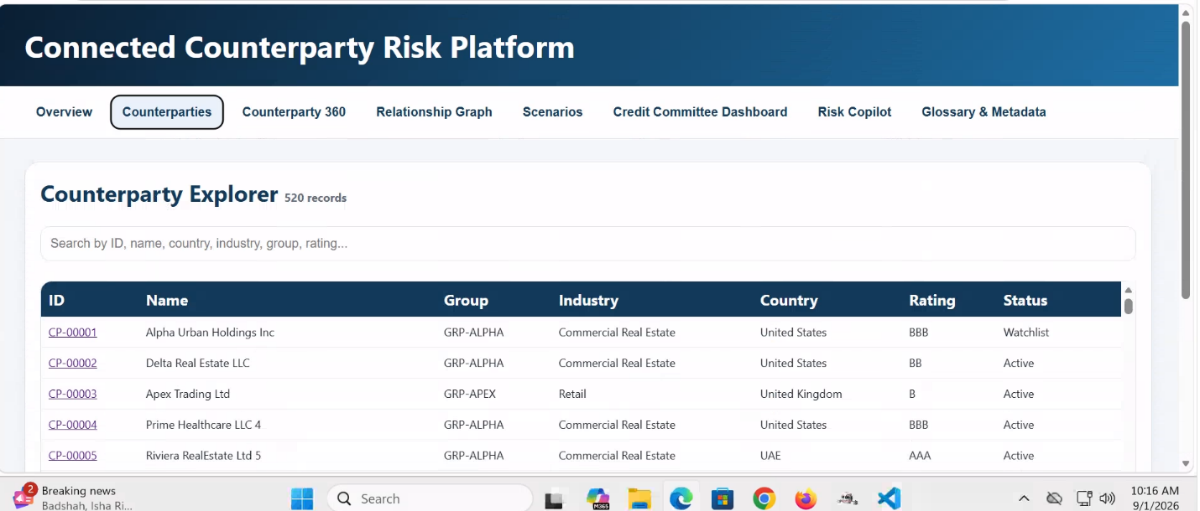
Fig 2: Tab 2
- Purpose of Tab 2 (Counterparties Explorer)

The Counterparties Explorer tab acts as the master directory of all counterparties present in the Connected Counterparty Risk Platform. It allows users to:
- Search and locate counterparties.
- Review basic counterparty information.
- Understand group affiliations.
- Identify industry and geographic exposure.
- View credit ratings.
- Monitor current status of an entity.
- Select counterparties for deeper analysis in the Counterparty 360 and Relationship Graph tabs.

In the screenshot, the platform contains 520 counterparties.

- Column Definitions

A. ID: A unique identifier assigned to each counterparty.
Example
- CP-00001
- CP-00002
- CP-00003

Purpose
The ID:
- Uniquely identifies each legal entity.
- Prevents confusion when multiple entities have similar names.
- Serves as the primary key in the database.
- Links records across all tabs.
Usage
When a user selects CP-00001, the system retrieves:
- Financial information
- Relationship network
- Risk scores
- Exposure details
- Scenario analysis
from other modules.

B. Name: Official legal name of the counterparty.

Example:
ID | Name
CP-00001 | Alpha Urban Holdings Inc
CP-00002 | Delta Real Estate LLC
CP-00003 | Apex Trading Ltd

Purpose
Used for:
- Entity identification
- Credit review
- Loan monitoring
- Regulatory reporting
- Risk assessment

C. Group: Represents the economic group or corporate group to which the counterparty belongs.
Examples:
Counterparty | Group
Alpha Urban Holdings Inc | GRP-ALPHA
Delta Real Estate LLC | GRP-ALPHA
Prime Healthcare LLC | GRP-ALPHA
Apex Trading Ltd | GRP-APEX

Why Important
A counterparty rarely operates independently.
Different entities may belong to the same:
- Holding company
- Business conglomerate
- Corporate family
Risk Benefits
Group identification helps identify:
- Hidden exposures
- Concentration risk
- Parent-subsidiary relationships
- Common ownership risk
Example
Bank exposure:
Entity | Exposure
Alpha Urban Holdings | $50M
Delta Real Estate | $30M
Prime Healthcare | $20M
Individually:
- No issue
Group total:
- $100M
This may breach concentration limits.

D. Industry: Business sector in which the company primarily operates.
Examples
- Commercial Real Estate
- Retail
- Manufacturing
- Banking
- Energy
- Telecommunications
Purpose
Industry classification allows:
- Sector risk analysis
- Industry concentration monitoring
- Economic stress testing
Example
Commercial Real Estate may currently carry higher risk due to:
- Falling occupancy rates
- Interest rate increases
- Valuation pressures
The platform can automatically identify these sector risks.

E. Country: Primary country of operation or incorporation.
Examples
Counterparty | Country
Alpha Urban Holdings | United States
Apex Trading Ltd | United Kingdom
Riviera Real Estate Ltd | UAE

Why Required
Country risk impacts:
- Political stability
- Currency risk
- Economic conditions
- Regulatory environment
- Sovereign risk
Example
A counterparty operating in a high-risk jurisdiction may receive a higher risk adjustment than the same company operating in a low-risk jurisdiction.

F. Rating: Represents the overall creditworthiness of the counterparty.
It estimates the probability that the entity may default or face financial distress.

How Rating is Calculated
The screenshot only shows the final rating. Since underlying data is not visible, a practical CCR platform normally converts a risk score into ratings.

Step 1: Calculate Risk Score
A common model:
Financial Strength (40%)
Measures:
- Leverage
- Liquidity
- Profitability
Score = 0-100

Concentration Risk (20%)
Measures:
- Sector concentration
- Geographic concentration
- Customer concentration
Score = 0-100

Event Risk (15%)
Measures:
- Legal cases
- Regulatory penalties
- ESG events
- Adverse news
Score = 0-100

Network Risk (25%)
Measures:
- Parent distress
- Subsidiary distress
- Ownership complexity
- Connected entity defaults
Score = 0-100

Overall Score Formula
Overall Score = (40% × Financial Strength) + (20% × Concentration Risk) + (15% × Event Risk) +
(25% × Network Risk)
Example:
Financial Strength = 80
Concentration Risk = 70
Event Risk = 90
Network Risk = 60

Overall Score= (80×0.40)+(70×0.20)+(90×0.15)+(60×0.25)
=32 +14 +13.5 +15
=74.5
Final Score = 75

4. Rating Thresholds
A typical banking standard is:
Score | Rating | Risk Level
90-100 | AAA | Very Low Risk
80-89 | AA | Low Risk
70-79 | A | Moderate-Low Risk
60-69 | BBB | Moderate Risk
50-59 | BB | Elevated Risk
40-49 | B | High Risk
30-39 | CCC | Very High Risk
20-29 | CC | Severe Risk
10--19 | C | Near Default
0-9 | D | Default

Rating Interpretation:
AAA
Characteristics
- Strong balance sheet
- Excellent liquidity
- Stable earnings
- Very low probability of default
Typical Probability of default: <0.10%

AA
Characteristics
- Very strong credit profile
- Minor vulnerabilities
Typical Probability of default: 0.10%-0.50%

A
Characteristics
- Healthy company
- Some exposure to economic cycles
Typical Probability of default: 0.50%-1.50%

BBB
Characteristics
- Investment grade
- Acceptable risk profile
Typical Probability of default: 1.50%-5%

BB
Characteristics
- Speculative
- Increased vulnerability
Typical Probability of default: 5%-10%

B
Characteristics
- Weak credit quality
Typical Probability of default: 10%-20%

CCC and Below
Characteristics
- Serious financial distress
Typical Probability of default: >20%

G. Status: Current monitoring status of the counterparty.
Common Values : Active
Meaning:
- Entity operating normally.
- No immediate concerns.
Example:
Status = Active
Rating = BBB
Normal monitoring.

Watchlist : Enhanced monitoring is required.
Triggers may include:
- Downgraded rating
- Adverse news
- Financial deterioration
- Covenant breach
- Parent company distress
Example:
Rating = BBB
Status = Watchlist
The counterparty may still be investment grade but requires closer review.

Example Using the First Record
Alpha Urban Holdings Inc
Field | Value
ID | CP-00001
Name | Alpha Urban Holdings Inc
Group | GRP-ALPHA
Industry | Commercial Real Estate
Country | United States
Rating | BBB
Status | Watchlist

Interpretation
- Belongs to Alpha Group.
- Operates within Commercial Real Estate.
- Located in the United States.
- Risk score likely falls within the BBB range (60-69).
- Investment grade but not very strong.
- Currently under enhanced monitoring due to watchlist status.
- Any deterioration in financial health, industry conditions, or connected entities could result in a downgrade to BB.

Summary:
Tab 2 serves as the master counterparty inventory. The columns provide:
- ID: Unique entity identifier.
- Name: Legal entity name.
- Group: Corporate ownership group.
- Industry: Business sector classification.
- Country: Geographic location and sovereign risk.
- Rating: Creditworthiness derived from risk scoring.
- Status: Current monitoring state (Active, Watchlist, etc.).
The rating is typically derived from a weighted risk score and mapped to a rating band using predefined thresholds, enabling credit officers to quickly assess the risk profile of every counterparty in the portfolio.

(Tab 3) Counterparty 360 - Detailed Functional & Calculation Document

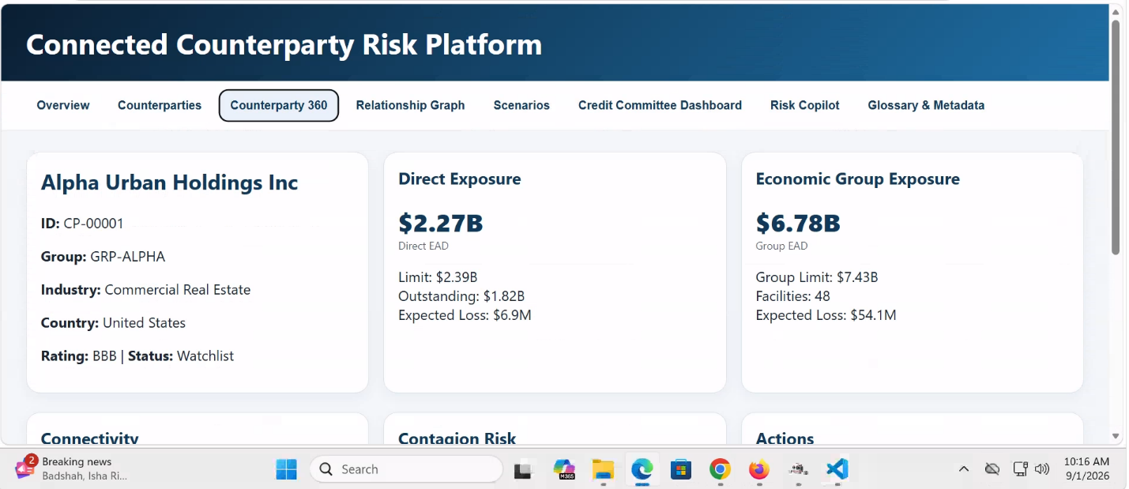
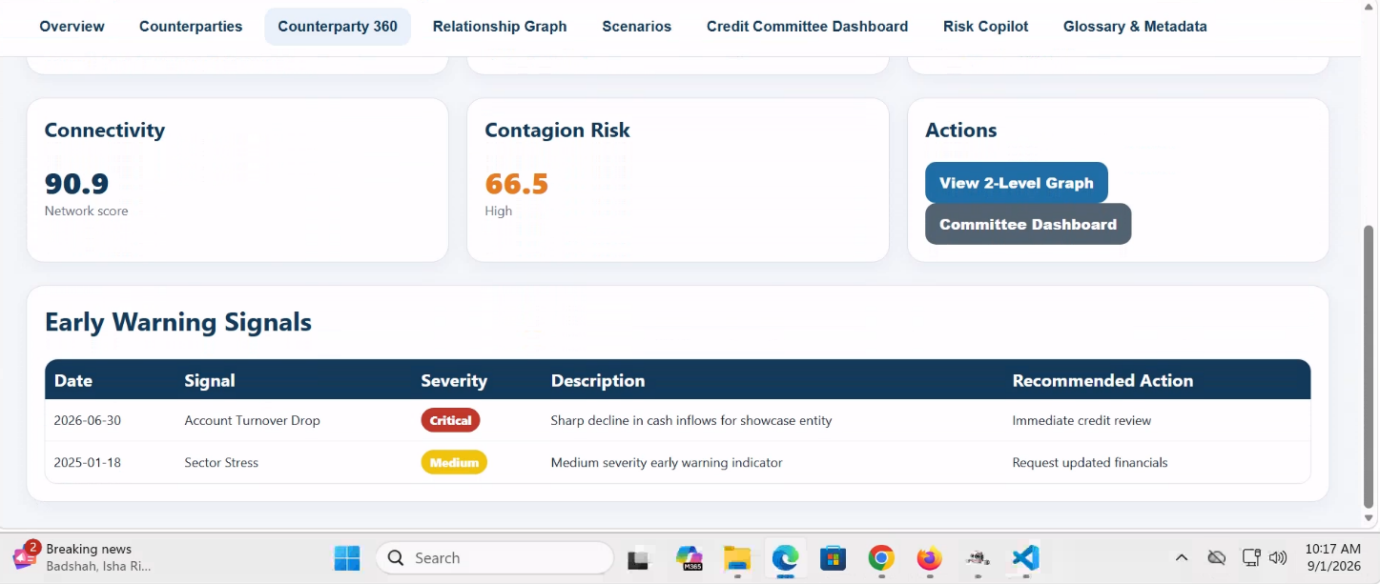

1. Purpose of Counterparty 360
The Counterparty 360 tab provides a consolidated view of a selected borrower/counterparty and its associated economic group. It helps relationship managers, credit officers, and risk committees understand:
- Individual exposure risk
- Group exposure risk
- Network connectivity risk
- Contagion risk
- Early warning indicators
- Recommended risk actions

2. Counterparty Information Section:
Counterparty Name: Alpha Urban Holdings Inc (The legal entity selected for analysis)
ID: CP-00001 (Unique identifier assigned to the counterparty)
Group: GRP-ALPHA (Economic group to which the entity belongs)
Industry: Commercial Real Estate (Primary industry classification of the entity)
Country: United States (Country of incorporation or primary operation)
Rating: BBB (Internal or external credit rating)
Status: Watchlist(Indicates enhanced monitoring due to increasing risk indicators)

3.Direct Exposure :
Direct Exposure represents the bank's total credit exposure to the selected entity only.
In the screenshot:
Direct Exposure (Direct EAD)
$2.27 Billion

3.1 EAD (Exposure at Default): Amount expected to be outstanding if the borrower defaults.
Formula
For funded facilities:
EAD = Outstanding Amount

For unfunded facilities:
EAD = Outstanding Amount+ (Undrawn Amount × CCF)
Where: CCF = Credit Conversion Factor

Example
Loan Outstanding= $1.50B
Undrawn Limit= $1.00B
CCF= 75%
Then: EAD=1.50B + (1.00B × 75%)
=1.50B + 0.75B
=2.25B

3.2 Limit
Maximum approved lending amount for the entity.

Example:
Limit = $2.39B
Formula
Limit Utilization % = Outstanding ÷ Limit × 100
Example: 82B ÷ 2.39B × 100 = 76.2%

Typical Thresholds
Utilization | Risk Level
<60% | Low
60-80% | Moderate
80-95% | High
>95% | Critical

3.3 Outstanding : Current amount drawn and owed.
Example:
Outstanding = $1.82B

3.4 Expected Loss (EL)
Expected annual credit loss from the exposure.
Formula
EL = EAD × PD × LGD
Where:
- EAD = Exposure at Default
- PD = Probability of Default
- LGD = Loss Given Default
Example
EAD= $2.27B , PD= 0.5% , LGD=60%
Calculation:
EL=2.27B × 0.005 × 0.60
=$6.81M

4. Economic Group Exposure: Total exposure to the entire connected economic group.
Includes:
- Parent entities
- Subsidiaries
- Sister companies
- Common UBO entities
- Joint ventures

Group EAD = $6.78B
Formula
Group EAD= Sum of EAD of all group entities
Example:
Entity | EAD
Alpha Holdings | 2.27B
Alpha Retail | 1.50B
Alpha Construction | 1.30B
Alpha Finance | 1.71B
Total = 6.78B

Group Limit= $7.43B
Formula
Group Limit=Σ Entity Credit Limits

Facilities
Total credit facilities extended across group entities.
Examples:
- Term Loans
- Revolving Credit Facilities
- Guarantees
- Letters of Credit
- Project Finance Facilities

Group Expected Loss= $54.1M
Formula
Group EL=Σ (Entity EAD × PD × LGD)
______________________________________________________________________________
- Connectivity Score:
Measures how strongly an entity is connected to other entities in the network.
High connectivity means distress can spread quickly.
Connectivity Score is an enterprise-wide score calculated once for each entity and reused across all tabs.
Connectivity Score = 40% Direct Relationship Score + 30% Indirect Relationship Score + 30% Relationship Diversity Score

Thresholds
Score | Band
0-25 | Low
26-50 | Moderate
51-75 | High
76-100 | Very High

Thus: 91.4 = Very High Connectivity

6. Contagion Risk
Measures probability that financial stress will spread from related entities to the selected counterparty.

Enterprise Contagion Score
Contagion Score = 35% Exposure Concentration + 35% Connectivity Score + 30% Connected Entity Stress

Threshold:
Score | Risk
0-25 | Low
26-50 | Moderate
51-75 | High
76-100 | Critical
Thus, 69.65 = High Contagion Risk

7. Actions Section
The system provides risk-based actions for users.
View 1-Level and 2-Level Graph

Committee Dashboard
Provides:
- Summary Credit committee
- Exposure metrics
- RWA impact
- Rating migration
- High-risk entities
Purpose:
- Escalation to senior credit management

8. Early Warning Signals (EWS)
Identifies early indicators of deterioration before default occurs.

Column 1: Date
Shows when the signal was triggered.

Column 2: Signal
Type of warning generated.
Examples:
Account Turnover Drop
Cash inflows or transaction volume decline sharply.
Sector Stress
Industry-wide deterioration.
Examples:
- Real estate slowdown
- Energy crisis
- Commodity crash

Column 3: Severity
Risk importance of the alert.

Severity Thresholds
Low: Score < 25
Monitor only.

Medium: 25-50
Enhanced review needed.

High: 51-75
Credit officer intervention.

Critical: >75
Immediate escalation.

4. Description
Provides detailed explanation of the trigger.
Example: Sharp decline in cash inflows for showcase entity
Possible cause:
- Revenue reduction
- Missed customer payments
- Liquidity stress

5. Recommended Action
Actions automatically suggested by the risk engine.
Example:
Immediate Credit Review
Used for:
- Critical EWS
- Rating downgrade
- High contagion risk

Request for Updated Financials
Used for:
- Sector stress
- Revenue deterioration
- Covenant breaches

Sample EWS Calculation Framework
Account Turnover Drop
Formula: Turnover Change % = (Current Quarter Turnover - Previous Quarter Turnover) ÷
Previous Quarter Turnover ×100
Decline | Severity
<10% | Low
10-20% | Medium
20-35% | High
>35% | Critical

Sector Stress:
Formula
Sector Stress Score= 50% Industry Default Rate + 30% Rating Downgrades + 20% Market Indicators

Thresholds:
Score | Severity
<25 | Low
25-50 | Medium
50-75 | High
>75 | Critical

Overall Interpretation of the Example Counterparty

Metric | Value | Assessment
Direct EAD | $2.27B | Large individual exposure
Group EAD | $6.78B | Significant group concentration
Connectivity | 90.9 | Very High
Contagion Risk | 66.5 | High
Status | Watchlist | Enhanced monitoring
Critical EWS | Account Turnover Drop | Immediate review required
Expected Loss | $6.9M | Material credit risk

Final Risk View
Alpha Urban Holdings shows high network connectivity, large group exposure, and elevated contagion risk. The account is already on the Watchlist, and the Critical Account Turnover Drop warning suggests possible emerging financial stress. Credit review refreshed financial statements, and deeper group-level analysis should be prioritized.

Tab 4: Relationship Graph
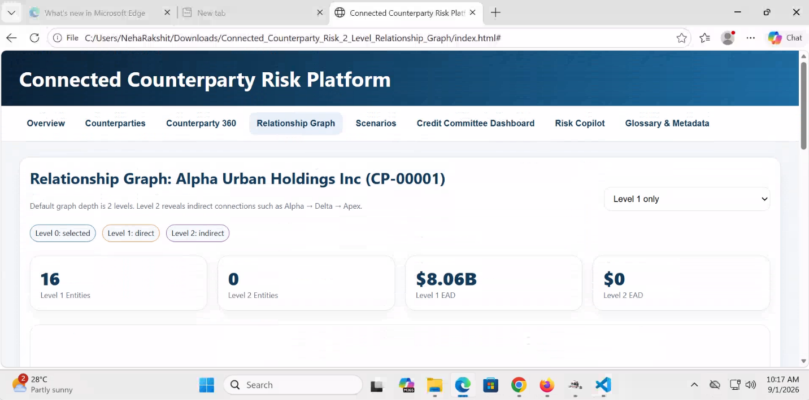

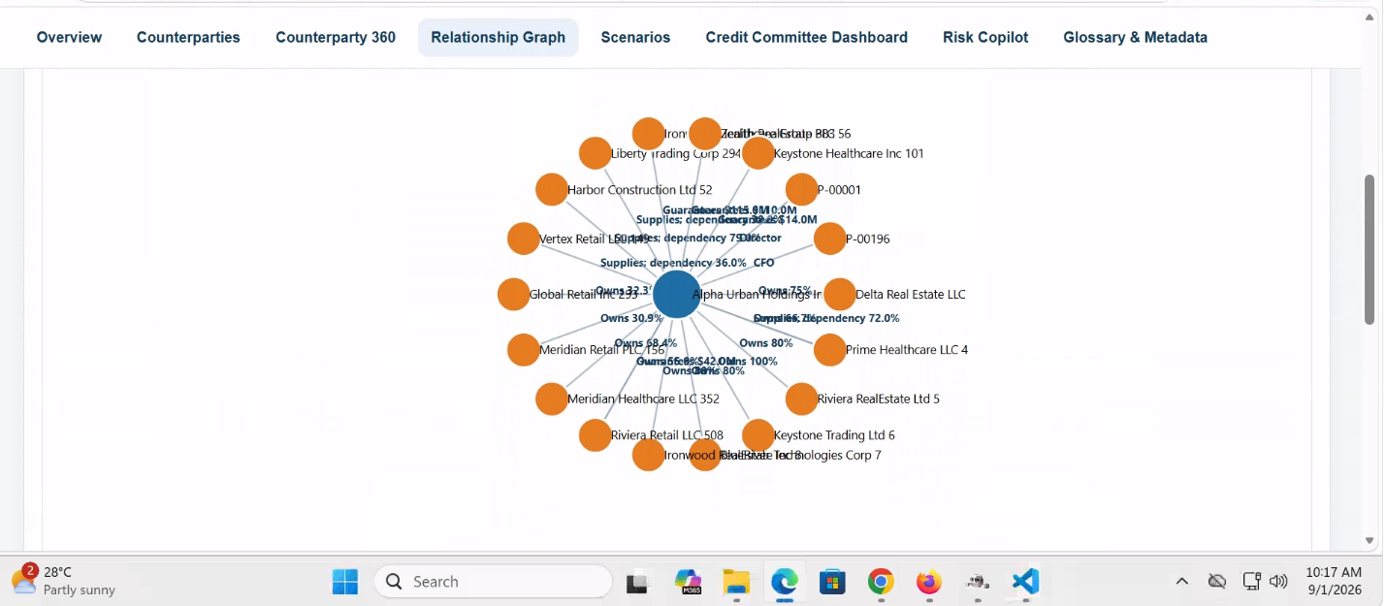
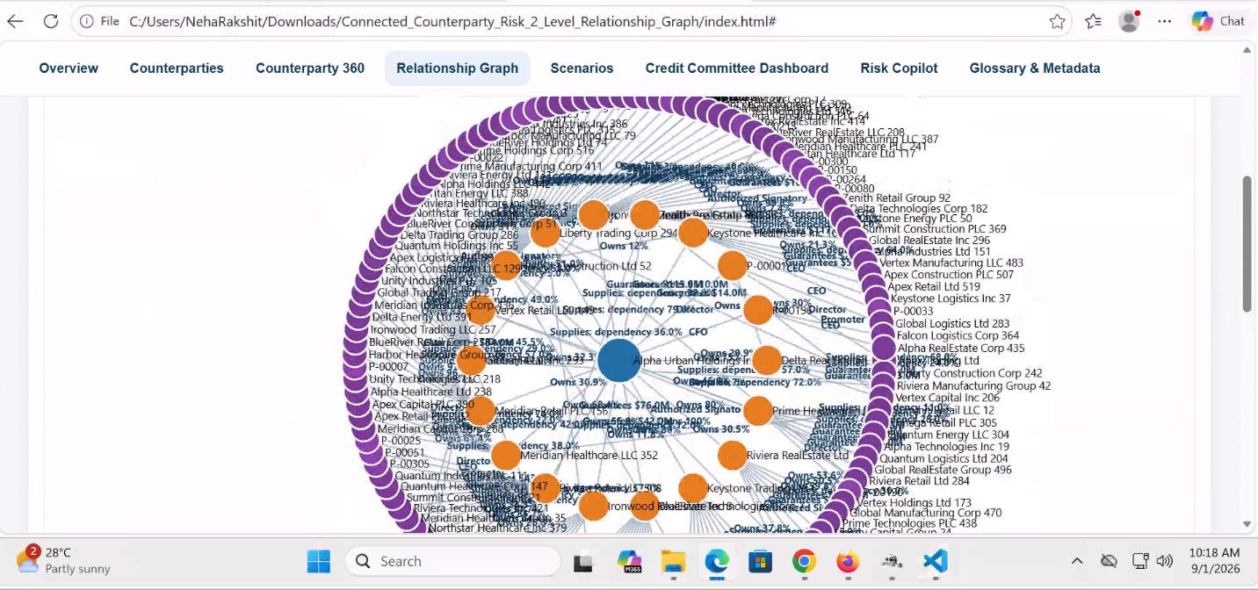
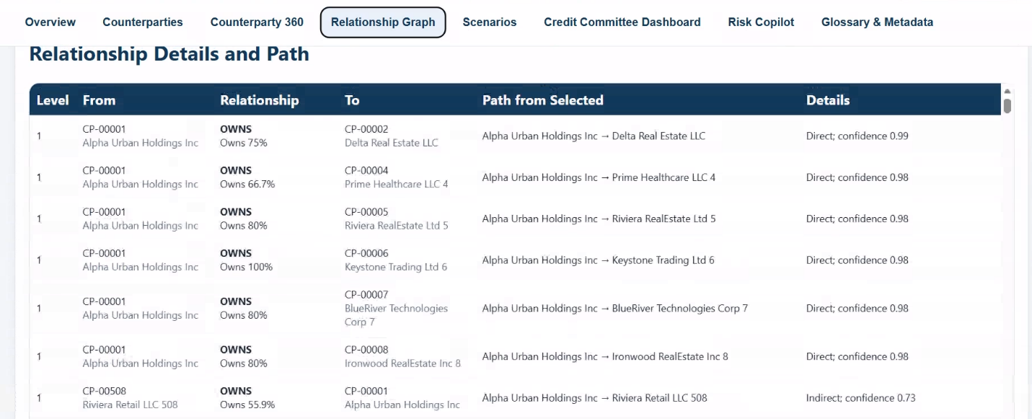
1. Purpose of Tab 4
The Relationship Graph tab provides a visual representation of all direct and indirect relationships connected to a selected counterparty. The main objective is to identify:
- Ownership structures
- Subsidiaries and parent companies
- Guarantees
- Shared management
- Supplier dependencies
- Beneficial ownership connections
- Indirect contagion paths
- Concentration of exposure within a connected group
This tab helps Credit Risk, Relationship Managers, Risk Officers, and Credit Committees understand how risk can propagate through a network of connected entities.

2. Components of Tab 4
A. Selected Counterparty
Example:
Alpha Urban Holdings Inc (CP-00001)
This is the entity currently under analysis.
Level Definitions
Level | Meaning
Level 0 | Selected entity
Level 1 | Direct relationships
Level 2 | Indirect relationships

Example:
Alpha Urban Holdings
|
Delta Real Estate
|
Apex Retail
Here:
- Alpha = Level 0
- Delta = Level 1
- Apex = Level 2

B. Graph Depth Filter
Dropdown:
Level 1 & Level 2
Purpose:
Controls how far the graph expands.
Level 1
Shows only direct connections.
Example:
Alpha
- Subsidiary A
- Guarantee B
- CEO Connection C
Level 2
Show relationships of related entities.
Example:
Alpha
├─ Subsidiary A
├─ Supplier X
├─ Parent Y
└─ Guarantee Z
Provides deeper contagion analysis.

C. Summary Cards
Formula:
Level 1: Count of all unique Level 1 relationship
Level 2 Entities: Count of all indirect nodes
Example:
Alpha → Delta → Apex
Apex becomes one Level 2 entity.

Level 1 EAD (Exposure at Default)
Represents the expected exposure if all connected Level 1 entities default.
Formula
Level 1 EAD = Sum (EAD of all Level 1 entities)
Example:
Entity | EAD
Delta | 2 B
Prime | 3 B
Keystone | 1 B
Riviera | 2.06 B

Total= 8.06 B
Level 2 EAD
Formula: Sum (EAD of all Level 2 entities)

D. Relationship Network Graph
This is the main visualization.

Blue Node
Selected Counterparty
Example: Alpha Urban Holdings

Orange Nodes
Level 1 entities
Examples visible:
- Delta Real Estate LLC
- Prime Healthcare LLC
- Riviera Real Estate Ltd
- Keystone Healthcare Inc
- Vertex Retail LLC
- Harbor Construction Ltd

Purple Nodes
Level 2 entities
Visible in third screenshot.
These are indirect relationships.
Example
Alpha
↓
Delta
↓
Apex
Apex appears purple.

3. Relationship Details and Path
The Relationship Details and Path table provides the tabular and auditable representation of the relationships displayed in the network graph. The graph helps users understand the network visually, while the table allows users to identify the exact source entity, target entity, relationship type, relationship level, path and confidence value.
The table contains the following columns:

Column | Required explanation
Level | Network distance of the displayed relationship from the selected counterparty
From | Source entity in the individual relationship edge
Relationship | Type and measurable value of the relationship
To | Target entity in the individual relationship edge
Path from Selected | Complete route from the selected counterparty to the connected entity
Details | Direct or indirect classification and relationship-level confidence

4. Explain each table column
3.1 Level
The Level column indicates the network layer at which the relationship is displayed.

Level | Meaning
0 | Selected counterparty
1 | Relationship directly connected to the selected counterparty
2 | Relationship reached through one intermediary entity
Level must be derived from the entity’s shortest path from the selected counterparty, not merely from the direction in which the edge is stored.
This prevents confusion between:
- graph level,
- edge direction, and
- relationship direction.
3.2 From
The From column identifies the source entity of the individual relationship.
The column should display:
- Counterparty ID
- Legal entity name

3.3 Relationship
The Relationship column identifies:
- the relationship type; and
- the associated relationship value.

3.4 To
The To column identifies the target entity of the individual relationship edge.
The column should display:
- Counterparty ID
- Legal entity name

3.5 Path from Selected

The Path from Selected column displays the complete route between the selected counterparty and the connected entity.

Path Length = number of relationship edges in the selected path

Where multiple paths exist, the platform should display the shortest eligible path by default. If more than one shortest path exists, the platform should prioritize the path with the highest combined path confidence. Alternative paths should remain available through drill-down.

3.6 Details

The Details column currently combines:
- connection classification; and
- relationship-level confidence.

Direct and indirect rules
Displayed value | Definition
Direct | The relationship or connected entity is reached without an intermediary
Indirect | The relationship or connected entity is reached through one or more intermediary entities

Recommended document clarification

The direct or indirect classification must be based on the full path from the selected counterparty. It should not be determined only by whether the current row contains the selected counterparty in the From or To column.

5. Add confidence score alignment

The existing methodology defines:

Confidence Score= 50% Source Quality + 30% Data Freshness + 20% Verification Status

Confidence Factor = Confidence Score ÷ 100

Displayed Confidence = Enterprise Confidence Score ÷ 100

Examples:
Enterprise confidence score | Displayed value | Band
99 | 0.99 | Very High
98 | 0.98 | Very High
73 | 0.73 | Medium

Use the thresholds already included in the methodology:
Confidence score | Decimal equivalent | Confidence band
90 to 100 | 0.90 to 1.00 | Very High
75 to 89 | 0.75 to 0.89 | High
50 to 74 | 0.50 to 0.74 | Medium
Below 50 | Below 0.50 | Low

7. Business Interpretation of the Screenshot
For Alpha Urban Holdings Inc (CP-00001):

Key Findings
- 16 direct connected entities.
- Level 1 exposure of $8.06B.
- Multiple ownership relationships above 75%, indicating strong control.
- Supplier dependencies exceed 70% in several connections, creating operational contagion risk.
- Multiple guarantee links are present.
- Shared management links such as CEO, CFO, Director and Authorized Signatory indicate governance concentration.
- Large interconnected corporate group with significant potential for default propagation.
- If Alpha Urban Holdings experiences distress, multiple connected entities are likely to be impacted due to ownership, dependency and guarantee relationships.

Overall Risk Assessment
Metric | Assessment
Ownership Concentration | High
Supplier Dependency | High
Management Interconnection | High
Guarantee Exposure | Medium-High
Contagion Potential | High
Network Complexity | High

Final Business Conclusion: Tab 4 is the primary network-risk and contagion-analysis view. It enables identification of concentration risk, ownership control, operational dependencies, guarantee obligations, and indirect risk transmission paths that may not be visible in traditional standalone credit analysis.

Tab 5: Scenarios (Contagion Scenarios)
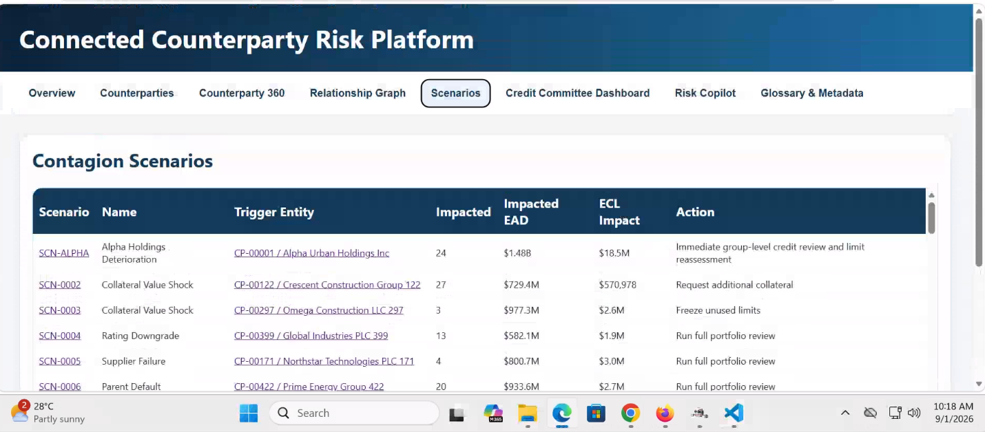

1. Purpose of Tab 5
The Scenarios tab enables Credit Risk teams, Relationship Managers, Portfolio Managers, and Credit Committees to assess the potential impact of adverse events occurring within a connected counterparty network.
The objective is to estimate:
- Risk propagation
- Financial impact
- Exposure impact
- Expected Credit Loss (ECL) impact
- Portfolio concentration impact
- Network contagion effect
- Management actions required
Scenario ID
Example:
SCN-0001
SCN-0002
SCN-0003
Purpose:
Provides unique identification of each scenario.
Used for:
- Audit trails
- Regulatory reporting
- Committee reviews
- Stress-testing documentation

5. Scenario Name
Describes the event being simulated.
Examples:
Alpha Holdings Deterioration
Assumes:
- Rating downgrade
- Financial deterioration
- Increased probability of default
Collateral Value Shock
Assumes:
- Significant collateral value decline
Supplier Failure
Assumes:
- Critical supplier unable to operate
Parent Default
Assumes:
- Parent entity defaults
- Stress transmitted to subsidiaries

6. Trigger Entity
The trigger entity is the entity where the scenario originates.
Example:
CP-00001: Alpha Urban Holdings Inc
The trigger entity becomes the source of contagion.
The scenario engine identifies all connected entities through:
- Parent links
- Subsidiary links
- Guarantees
- Common shareholders
- Common directors
- Suppliers
- Customers
- Funding relationships
- Shared collateral

7. Impacted Entities
Represents the number of entities likely to experience material stress due to the scenario.
Calculation
An entity is considered impacted when:
Scenario Transmission Score ≥ 25
Scenario Transmission Score
Scenario Transmission Score = Relationship Score × Connected Entity Stress Score × Confidence
Factor ÷ 100
Using the same methodology already used in Network Risk calculations.
Example
Assume:
Relationship Score = 85
Connected Stress Score = 70
Confidence Score = 95
Confidence Factor = 0.95
Then:
Transmission Score = 85 × 70 × 0.95 ÷100
= 56.53
Since:
56.53 > 25
entity is impacted.

8. Impacted EAD
Represents total exposure potentially affected by the scenario.
Formula
Impacted EAD = Sum (EAD of all impacted entities)
Where: Impacted Entity = Transmission Score ≥ 25

Example
Entity | EAD
Delta Real Estate | $600M
Prime Healthcare | $350M
Riviera Real Estate | $530M

Impacted EAD = 600 + 350 + 530 = $1.48B

9. Scenario Severity Score
Measures overall severity of the simulated event.
Formula
Scenario Severity Score = 40% Trigger Entity Stress + 35% Connectivity Score
+ 25% Contagion Score
Uses existing enterprise metrics only.
Example
Trigger Stress = 85
Connectivity = 92
Contagion = 70
Scenario Severity = 85 × 40% + 92 × 35% + 70 × 25%
=34 + 32.2 + 17.5
=83.7

10. Scenario Severity Bands
Score | Severity
0-25 | Low
26-50 | Moderate
51-75 | High
76-100 | Critical
Example: 83.7 = Critical

11. ECL Impact
Expected credit loss Impact estimates incremental expected loss caused by the scenario.
This should remain consistent with Tab 3.
Existing Formula
Expected Loss = EAD × PD × LGD

Scenario ECL Impact
Scenario ECL Impact = Scenario ECL - Current ECL
Where: Scenario ECL= Impacted EAD × Stressed PD × Stressed LGD

Example
Current: Impacted EAD = $1.48B
PD = 1%
LGD = 35%

Current EL = 1.48B × 1% × 35%
= $5.18M
Scenario:
PD = 4%
LGD = 40%
Scenario EL = 1.48B × 4% × 40%
= $23.68M
ECL Impact
23.68M - 5.18M
= $18.50M
Matches the business interpretation shown in the screen.

12. Scenario Contagion Impact
Measures how much the enterprise Contagion Score changes because of the event.
Already defined in Tab 3:
Contagion Score = 35% Exposure Concentration + 35% Connectivity Score
+ 30% Connected Entity Stress

Scenario Contagion Score
Replace current stress values with stressed values.
Example:
Current: Contagion = 68
Scenario: Contagion = 84
Increase: +16 points

13. Portfolio Impact
Measures percentage of portfolio exposure affected.
Formula
Portfolio Impact % = Impacted EAD ÷ Portfolio EAD ×100
Example
Impacted EAD: $1.48B
Portfolio EAD: $12.5B
Portfolio Impact =1.48 ÷ 12.5 ×100
=11.84%

14. Recommended Action Engine
Actions are rule based.
Critical Scenario
Conditions : ≥ 75
Actions:
- Immediate Credit Review
- Senior Committee Escalation
- Limit Reduction Assessment

High Scenario
Conditions: 50-75
Actions:
- Portfolio Review
- Enhanced Monitoring
- Financial Refresh Request

Moderate Scenario
Conditions: 25-50
Actions:
- Watchlist Review
- Relationship Assessment

Low Scenario
Conditions: Below 25
Actions:
- Standard Monitoring

15. Scenario Detail Drill Down
When the user clicks a scenario, the system should display:
Trigger Entity
- Counterparty Name
- ID
- Rating
- Final Risk Score
Network Analysis
- Connectivity Score
- Network Risk Score
- Contagion Score
- Impacted Entities
Financial Impact
- Current ECL
- Scenario ECL
- Incremental ECL
Transmission Path
Example
Alpha Holdings
↓
Delta Real Estate
↓
Prime Healthcare
↓
Northstar Retail
Using the identical relationship paths already shown in Tab 4.

16. Overall Interpretation
A scenario is considered dangerous when:
- Connectivity Score is high
- Network Risk Score is high
- Contagion Score is high
- Impacted EAD is large
- Incremental ECL is material

Tab 6: Credit Committee Dashboard
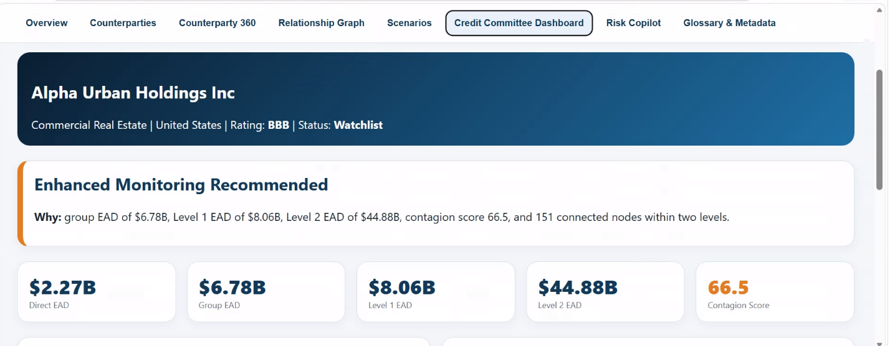

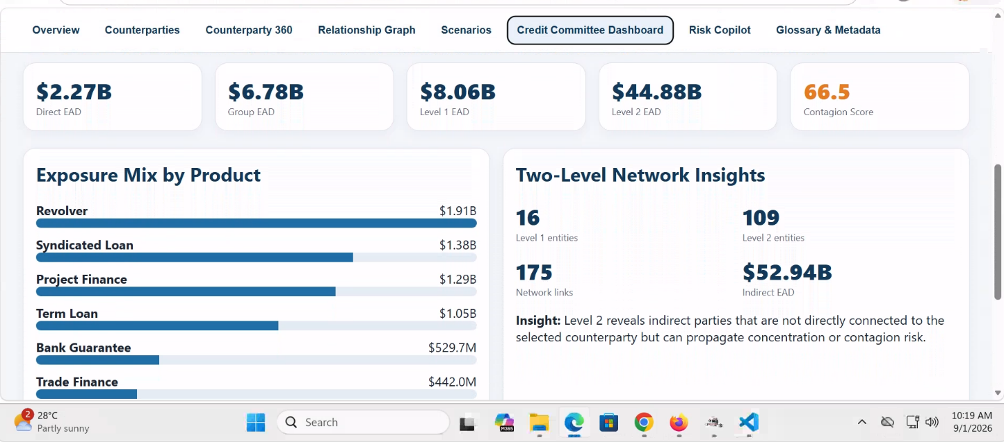

Purpose of Tab 6
The Credit Committee Dashboard is the executive decision-support view of the Connected Counterparty Risk Platform.
The objective of Tab 6 is to provide committee members with a consolidated view of:
- Current credit exposure
- Group concentration
- Connected counterparty risk
- Network contagion risk
- Portfolio concentration
- Product concentration
- Recommended committee actions
- Escalation requirements
This dashboard is designed for:
- Credit Committee Members
- CRO Office
- Senior Credit Officers
- Portfolio Risk Teams
- Risk Governance Teams
- Board Risk Committees

- Executive Header Section
This section provides immediate context regarding the selected entity.

Example:
Alpha Urban Holdings Inc
Commercial Real Estate
United States
Rating: BBB
Status: Watchlist

4. Committee Recommendation Banner
The most important component of the dashboard.
Example: Enhanced Monitoring Recommended

Recommendation Engine
The platform evaluates:
- Final Risk Score
- Network Risk Score
- Contagion Score
- Group EAD
- Watchlist status
- Early Warning Signals
and generates a recommendation.

Decision Formula
Committee Risk Score
Committee Risk Score = 40% Final Counterparty Risk Score + 30% Contagion Score +
20% Concentration Risk Score+10% Event Risk Score
All component scores already exist in Tab 1 and Tab 3.
Committee Risk Bands
Score | Recommendation
0-20 | Standard Monitoring
20-40 | Periodic Review
40-60 | Enhanced Monitoring
60-80 | Credit Review Required
80-100 | Immediate Committee Escalation

5. Why Section
Example shown:
Group EAD of $6.78B
Level 1 EAD of $8.06B
Level 2 EAD of $44.88B
Contagion Score 66.5
151 Connected Nodes

Purpose
Provides explainability behind the recommendation.
This allows committee members to understand:
- Why is entity risky
- Why monitoring is required
- Which exposures are driving concern

6. Direct EAD Card
Represents exposure to the selected legal entity.
Same definition as Tab 3.
Formula
Direct EAD = Drawn Exposure + (Undrawn Exposure × CCF)

7. Group EAD Card
Total exposure across the economic group.
Same calculation used in Tab 3.
Formula
Group EAD = Sum of EAD for all entities within the group
Includes:
- Parent
- Subsidiaries
- Affiliates
- Connected Group Members

8. Level 1 EAD Card
Exposure connected through direct relationships.
Examples:
- Parent/Subsidiary
- Guarantor
- UBO
- Common Shareholder
- Supplier
- Customer

Formula
Level 1 EAD = Sum of EAD of all Level 1 connected entities
Uses identical relationship definitions from Tab 4.

9. Level 2 EAD Card
Exposure within indirect relationships.
Examples:
Alpha
↓
Delta
↓
Omega
Omega becomes a Level 2 entity.

Formula
Level 2 EAD = Sum of EAD of all Level 2 connected entities
Uses the same graph hierarchy from Tab 4.

10. Contagion Score Card
Measures probability of stress propagation through the network.
Uses enterprise Contagion Score.

Formula
Contagion Score = 35% Exposure Concentration + 35% Connectivity Score
+ 30% Connected Entity Stress

Contagion Thresholds
Score | Risk
0-25 | Low
26-50 | Moderate
51-75 | High
76-100 | Critical

11. Exposure Mix by Product
Shows how exposure is distributed across products.
Examples shown:
- Revolver
- Syndicated Loan
- Project Finance
- Term Loan
- Bank Guarantee
- Trade Finance

Purpose
Allows committee to see concentration by product.

Product Exposure Formula
For each product:
Product Exposure = Sum of EAD for facilities belonging to that product

Product Concentration %
Product Concentration % = Product EAD ÷ Total EAD ×100

Example
Revolver: $1.91B
Total EAD: $6.78B
=1.91 ÷ 6.78 ×100
= 28.17%

12. Product Concentration Risk Score
Aligned with Tab 1 Concentration Risk methodology.
Formula
Product Concentration Score = Largest Product Exposure %

Thresholds
Largest Product % | Rating | Normalized
Below 10% | 1 | 0
10%-20% | 2 | 25
20%-35% | 3 | 50
35%-50% | 4 | 75
Above 50% | 5 | 100

13. Two-Level Network Insights
16 Level 1 Entities
109 Level 2 Entities
175 Network Links
$52.94B Indirect Exposure

Level 1 Entities: Direct relationships only.

Level 2 Entities: Indirect relationships only.

Network Links
Total number of relationship edges
Examples:
- Parent
- Supplier
- Customer
- Guarantee
- UBO

Indirect EAD
Indirect EAD = Level 1 EAD + Level 2 EAD
Sum of EAD of all graph-connected entities excluding source entity depending on implementation.

14. Network Complexity Score
To support committee decisions, a network complexity indicator should be introduced.
Formula
Network Complexity Score = 40% Normalized Node Count + 35% Normalized Link Count
+ 25% Connectivity Score
Connectivity Score already comes from Tab 3.
Thresholds
Score | Risk
0-25 | Low
26-50 | Moderate
51-75 | High
76-100 | Critical

16. Committee Dashboard Summary
For the example shown:
Metric | Value | Assessment
Direct EAD | $2.27B | Large Single Exposure
Group EAD | $6.78B | High Concentration
Level 1 EAD | $8.06B | Significant Direct Network Exposure
Level 2 EAD | $44.88B | Extremely Large Indirect Exposure
Contagion Score | 66.5 | High
Level 1 Entities | 16 | Large Network
Level 2 Entities | 109 | Extensive Indirect Network
Network Links | 175 | High Complexity
Rating | BBB | Moderate Credit Quality

Final Business Conclusion
The Credit Committee Dashboard is the executive decision-making layer of the platform. It consolidates exposure, concentration, connectivity, contagion, product concentration, and network complexity information into a single view that enables fast credit decisions.

Tab 7: Risk Copilot
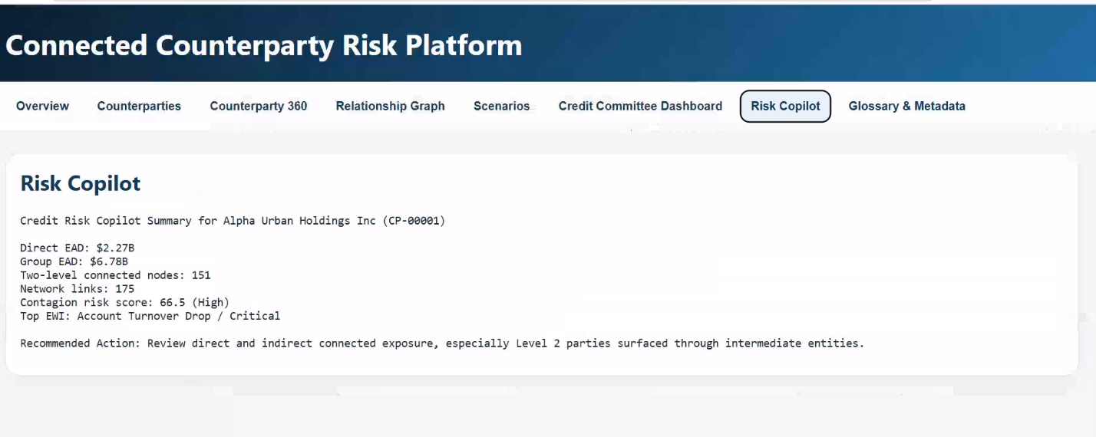
1. Purpose of Tab 7
The Risk Copilot tab is the explainability and decision-support layer of the Connected Counterparty Risk Platform.
The Risk Copilot consolidates risk information generated by Tabs 1 to 6 and converts that information into a clear business summary for credit officers, relationship managers, risk analysts, portfolio managers, and credit committee members.
The Risk Copilot answers the following questions:
- What is the current risk profile of the selected counterparty?
- What are the primary risk drivers?
- How much direct and group exposure exists?
- How large is the connected network?
- What is the current contagion risk?
- Which Early Warning Indicator requires attention?
- What action should the user take?
- Which direct and indirect connected entities should be reviewed?
The Risk Copilot must explain existing enterprise scores and metrics. The Risk Copilot must not create, override, or recalculate enterprise scores.

Tab 8: Glossary & Metadata
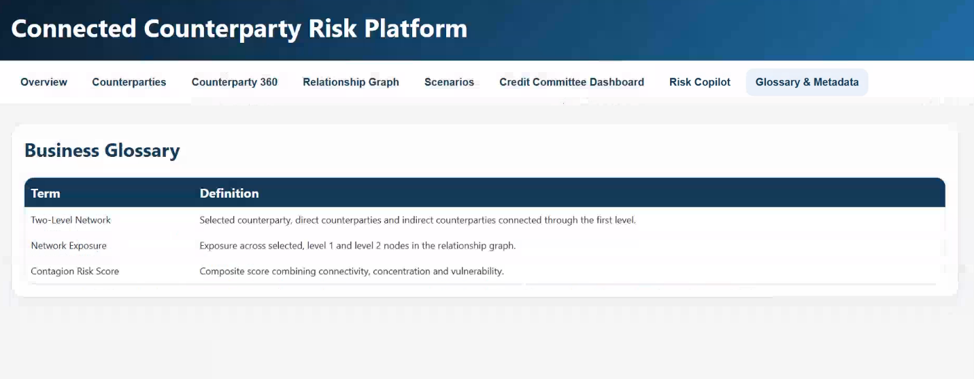
The tab is designed to act as the authoritative reference point for all definitions, formulas, thresholds, relationship classifications, data sources, and methodology versions used across Tabs 1 to 7.

1. Purpose of Tab 8
The Glossary & Metadata tab provides a centralized business glossary and methodology catalogue for the Connected Counterparty Risk Platform.
The screenshot currently displays the following business terms:
- Two-Level Network
- Network Exposure
- Contagion Risk Score
The final tab should expand this structure so users can understand:
- What does each metric means
- How each metric is calculated
- Which thresholds apply
- Whether a higher score means higher or lower risk
- Which tab owns the calculation
- Which source system supplies the data
- When the metric was last refreshed
- Which methodology version was used
- Who owns and approves the definition
Tab 8 does not calculate risk scores. It documents and governs the calculations performed by the central risk engine.

